**LEG Team**

**Developer’s Manual – version 1**

**4/3/2019**

**Environment setup for our platform.**

Our game is using Unity version 2018.3.9 to coding and developing. If need download the version 2018.3.9, please go to <https://unity3d.com/unity/whats-new/2018.3.9> to download this version for Windows and Mac operating system.

For Windows’ user, when click into the download link above, find the words: “Component Installers Windows” and click the first line under that which is “Unity Editor(64-bit)”.

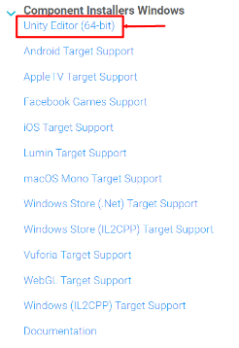

Same as the Mac user, click into the download link above, find the words: “Component Installers MacOS” and click the first line under that which is “Unity Editor”.

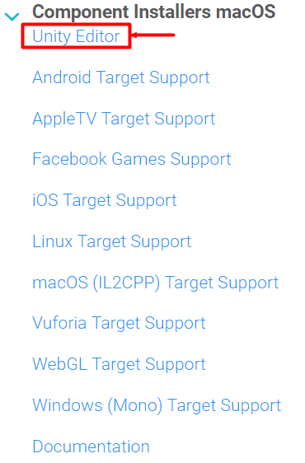

If have any issues about Unity installation, please visit <https://cs.hofstra.edu/docs/pages/guides/unity_install.html>, there is an introduction about how to set up unity on computer.

**Context diagram and Class diagram**



* For the context diagram, the mean idea and game mode is user give input to movement change the position and rotation of the character to avoid hit obstacle and collect the coins in the game. The movement and obstacle will visualize in the play screen. When there is an action (movement, hitting, etc…), it will send signal to the Gamemanager to check whether there is any situation will happen after.

**Our game name: BeatRunner**

Our game separates into several parts below: (the class diagram is the draft of our game, the description is based on the code of every part)

* Gamemanager

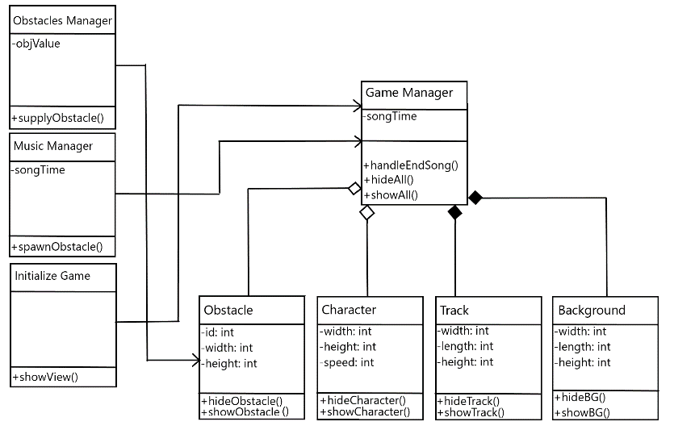

* Gamemanager is controlling whole part of the game. It gives a initialize position of character, which is in the middle of the screen. It gives a initialize speed of the obstacles moving speed, force and random obstacles size. It controls the character when hit obstacle will end game and if restart game, it needs to redo the initialize from the game. When end the game, it will send signal to the gamemanger and open menu of game.
* Sound

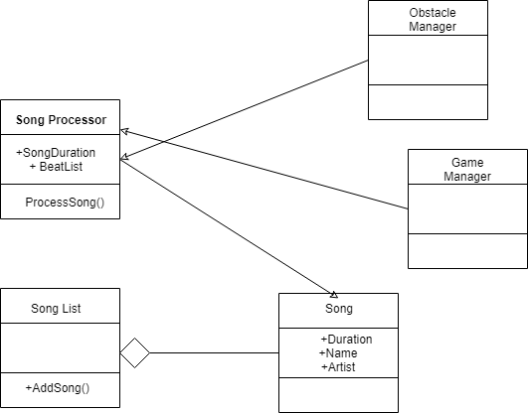

* Sound is about some music effect on the game. It has a background music start during the game start and when end the sound the game will end. It also has a collision music when character hit the obstacle.
* HUD

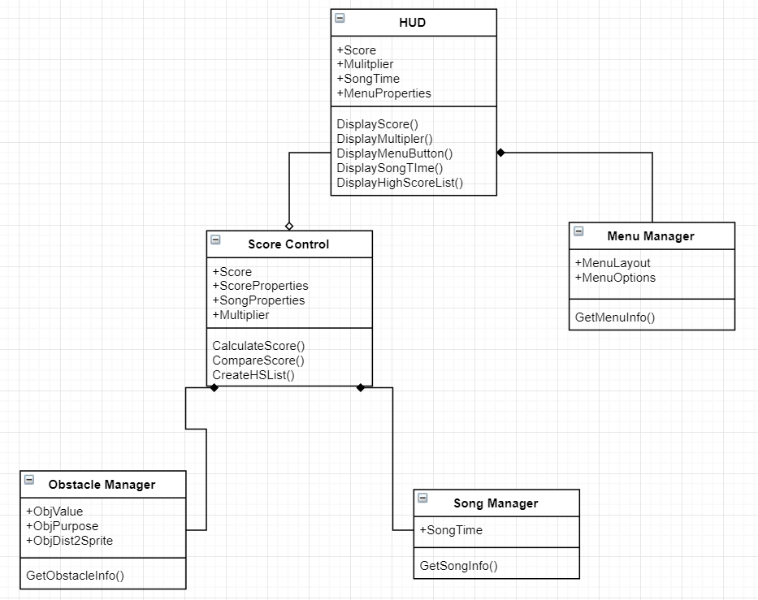

* HUD is about the game background and some button setting during the game. Our background and path will have animation during the game which sync with the music as well. There is a restart and menu button at the upper right corner of the game, which user can choose to restart and end game, and then it will call to gamemanger to jump to the function which user choose.
* HUD also has a score collect system, which will calculate the score of the user when its playing and the collection number of the coins and that will show on the upper left corner of the screen. Once end the game whether hit obstacle or end music, the score of this turn will be collected and stored in the game database and allow users to upload their score.
* HUD have a game progress bar and mini map of obstacle at the bottom of the game that shows the length of game destination. This part is use for debugging, not visible for players
* Menu

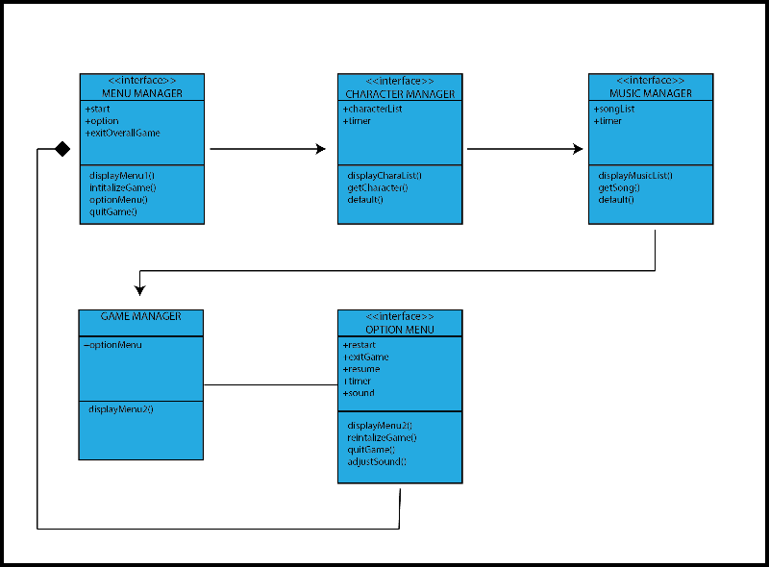

* Menu shows our team logo and different buttons. There is three now which for: start game, option and quit. When click start, it will call to gamemanager and give initialize of game and start the game for users. For option parts, there is three choices: volume, instructions and brightness. This part will change the volume in the computer system, which need permission of the computer same as the brightness. The instructions give a brief introduction of controller of characters.
* Obstacle

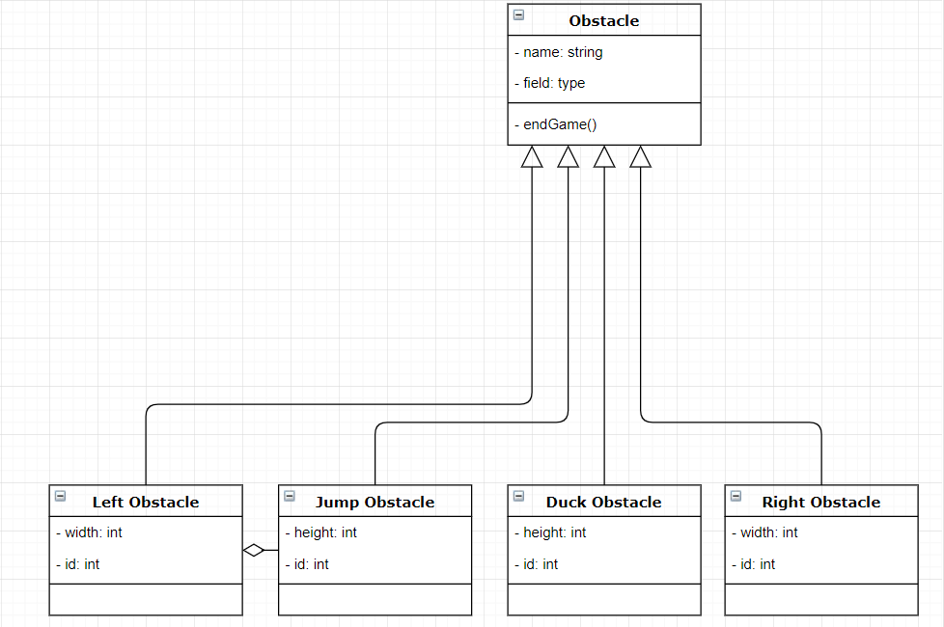

* Obstacle part controls its speed, size, position and force. In this part we use “Vector” for changing position and “Quaternion” for changing rotation.
* Character

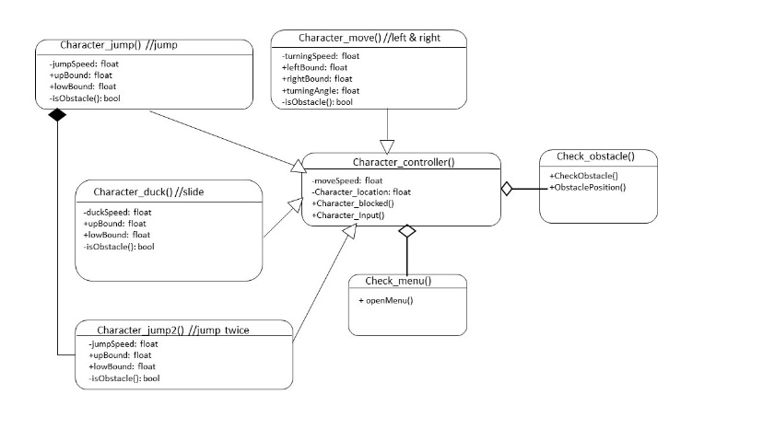

* Character part controls the movement of the characters, which is left, right, jump and slide. In this part we use “Vector” for changing position and “Quaternion” for changing rotation.

1. For the move of left and right, the code is in the “character_move_1.cs.” there will be a check for left or right, “goingLeft” and “goingRight”, which is make not go out of game boundary. If that is true, use “Input.GetKeyUp(KeyCode.key)” to move the character and use “GetComponent<Rigidbody>()” to change its position, speed and force.
2. Jump part is in the “character_jump_1.cs” which is similar to move part
3. Slide part have two different file which is “character_slide_1.cs” and “character_slide_3.cs”. Firsts code is slide by y position and the second one is toward x position. Both code is same and just distinguish the rotate position. In the code there is “slide_speed” which need developer to add in game setting so that can give an initial speed of rotate and can change the “Time.deltaTime” which effect the “slide_angluar” of the character. There will be a check for not allow slide and jump at same time.
4. Obstacle check is in the “hit_obstacle.cs”, which check if hit obstacle destroy the character and return to score or menu.

* Character part have a camera follow by the character, use “Vector3 offset” to initialize the camera and follow by the position of the character.